Hierarchical Inheritance

📌 Definition:
# Source: AI Source: Provided by: [Data Path: Persons Table -> ID Column: 1, Name_En Column: Motasem Essam] -> From: [ChatGPT] on [12/9/2025]
Hierarchical inheritance is a type of inheritance where multiple child classes inherit from a single parent class.

🧠 Simple idea:
# Source: AI Source: Provided by: [Data Path: Persons Table -> ID Column: 1, Name_En Column: Motasem Essam] -> From: [ChatGPT] on [12/9/2025]
Hierarchical inheritance = “One parent → Many children” 👨‍👧‍👦

🔍 Key characteristics:
# Source: AI Source: Provided by: [Data Path: Persons Table -> ID Column: 1, Name_En Column: Motasem Essam] -> From: [ChatGPT] on [12/9/2025]
- 🔗 One parent (base) class
- 👨‍👩‍👧‍👦 Multiple child classes
- ♻️ All children share common features from the parent
- ➕ Each child can have its own unique features
- 🧩 Reduces code duplication

📌 Example (Java-style):
# Source: AI Source: Provided by: [Data Path: Persons Table -> ID Column: 1, Name_En Column: Motasem Essam] -> From: [ChatGPT] on [12/9/2025]
Parent class:
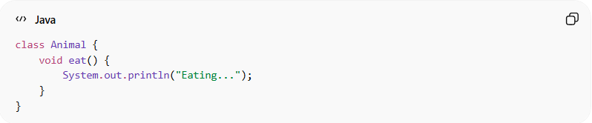
class Animal {
void eat() {
System.out.println("Eating...");
}
}

Child classes:
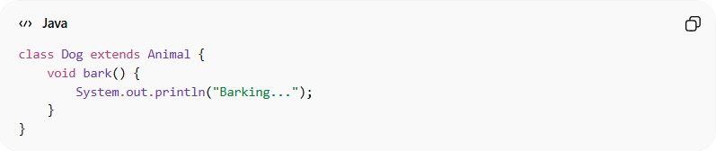
class Dog extends Animal {
void bark() {
System.out.println("Barking...");
}
}
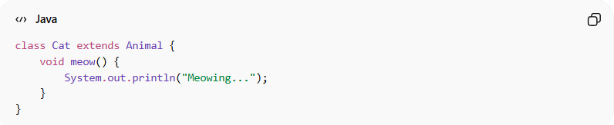
class Cat extends Animal {
void meow() {
System.out.println("Meowing...");
}
}

Usage:
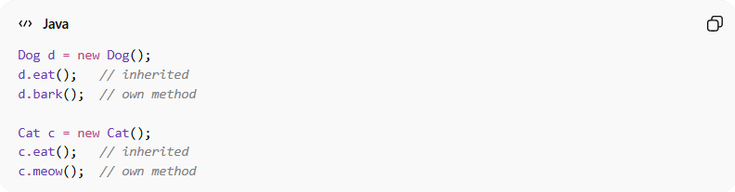
Dog d = new Dog();
d.eat(); // inherited
d.bark(); // own method

Cat c = new Cat();
c.eat(); // inherited
c.meow(); // own method

🆚 Structure visualization:
# Source: AI Source: Provided by: [Data Path: Persons Table -> ID Column: 1, Name_En Column: Motasem Essam] -> From: [ChatGPT] on [12/9/2025]
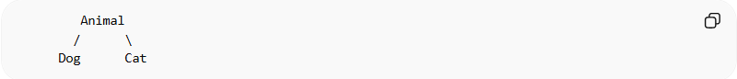
Animal
/ \
Dog Cat

🎯 Why hierarchical inheritance is useful:
# Source: AI Source: Provided by: [Data Path: Persons Table -> ID Column: 1, Name_En Column: Motasem Essam] -> From: [ChatGPT] on [12/9/2025]
- ♻️ Promotes code reuse
- 🧱 Organizes related classes under one parent
- 🔄 Reduces duplication of common code
- 🧩 Models real-world relationships

🎯 Summary:
# Source: AI Source: Provided by: [Data Path: Persons Table -> ID Column: 1, Name_En Column: Motasem Essam] -> From: [ChatGPT] on [12/9/2025]
Hierarchical inheritance allows multiple classes to inherit from a single parent class, creating a tree-like structure that promotes reuse and organization.

